Gabriela García de Cortázar G.

Architectural Association

**Valparaiso School (1952-today)**

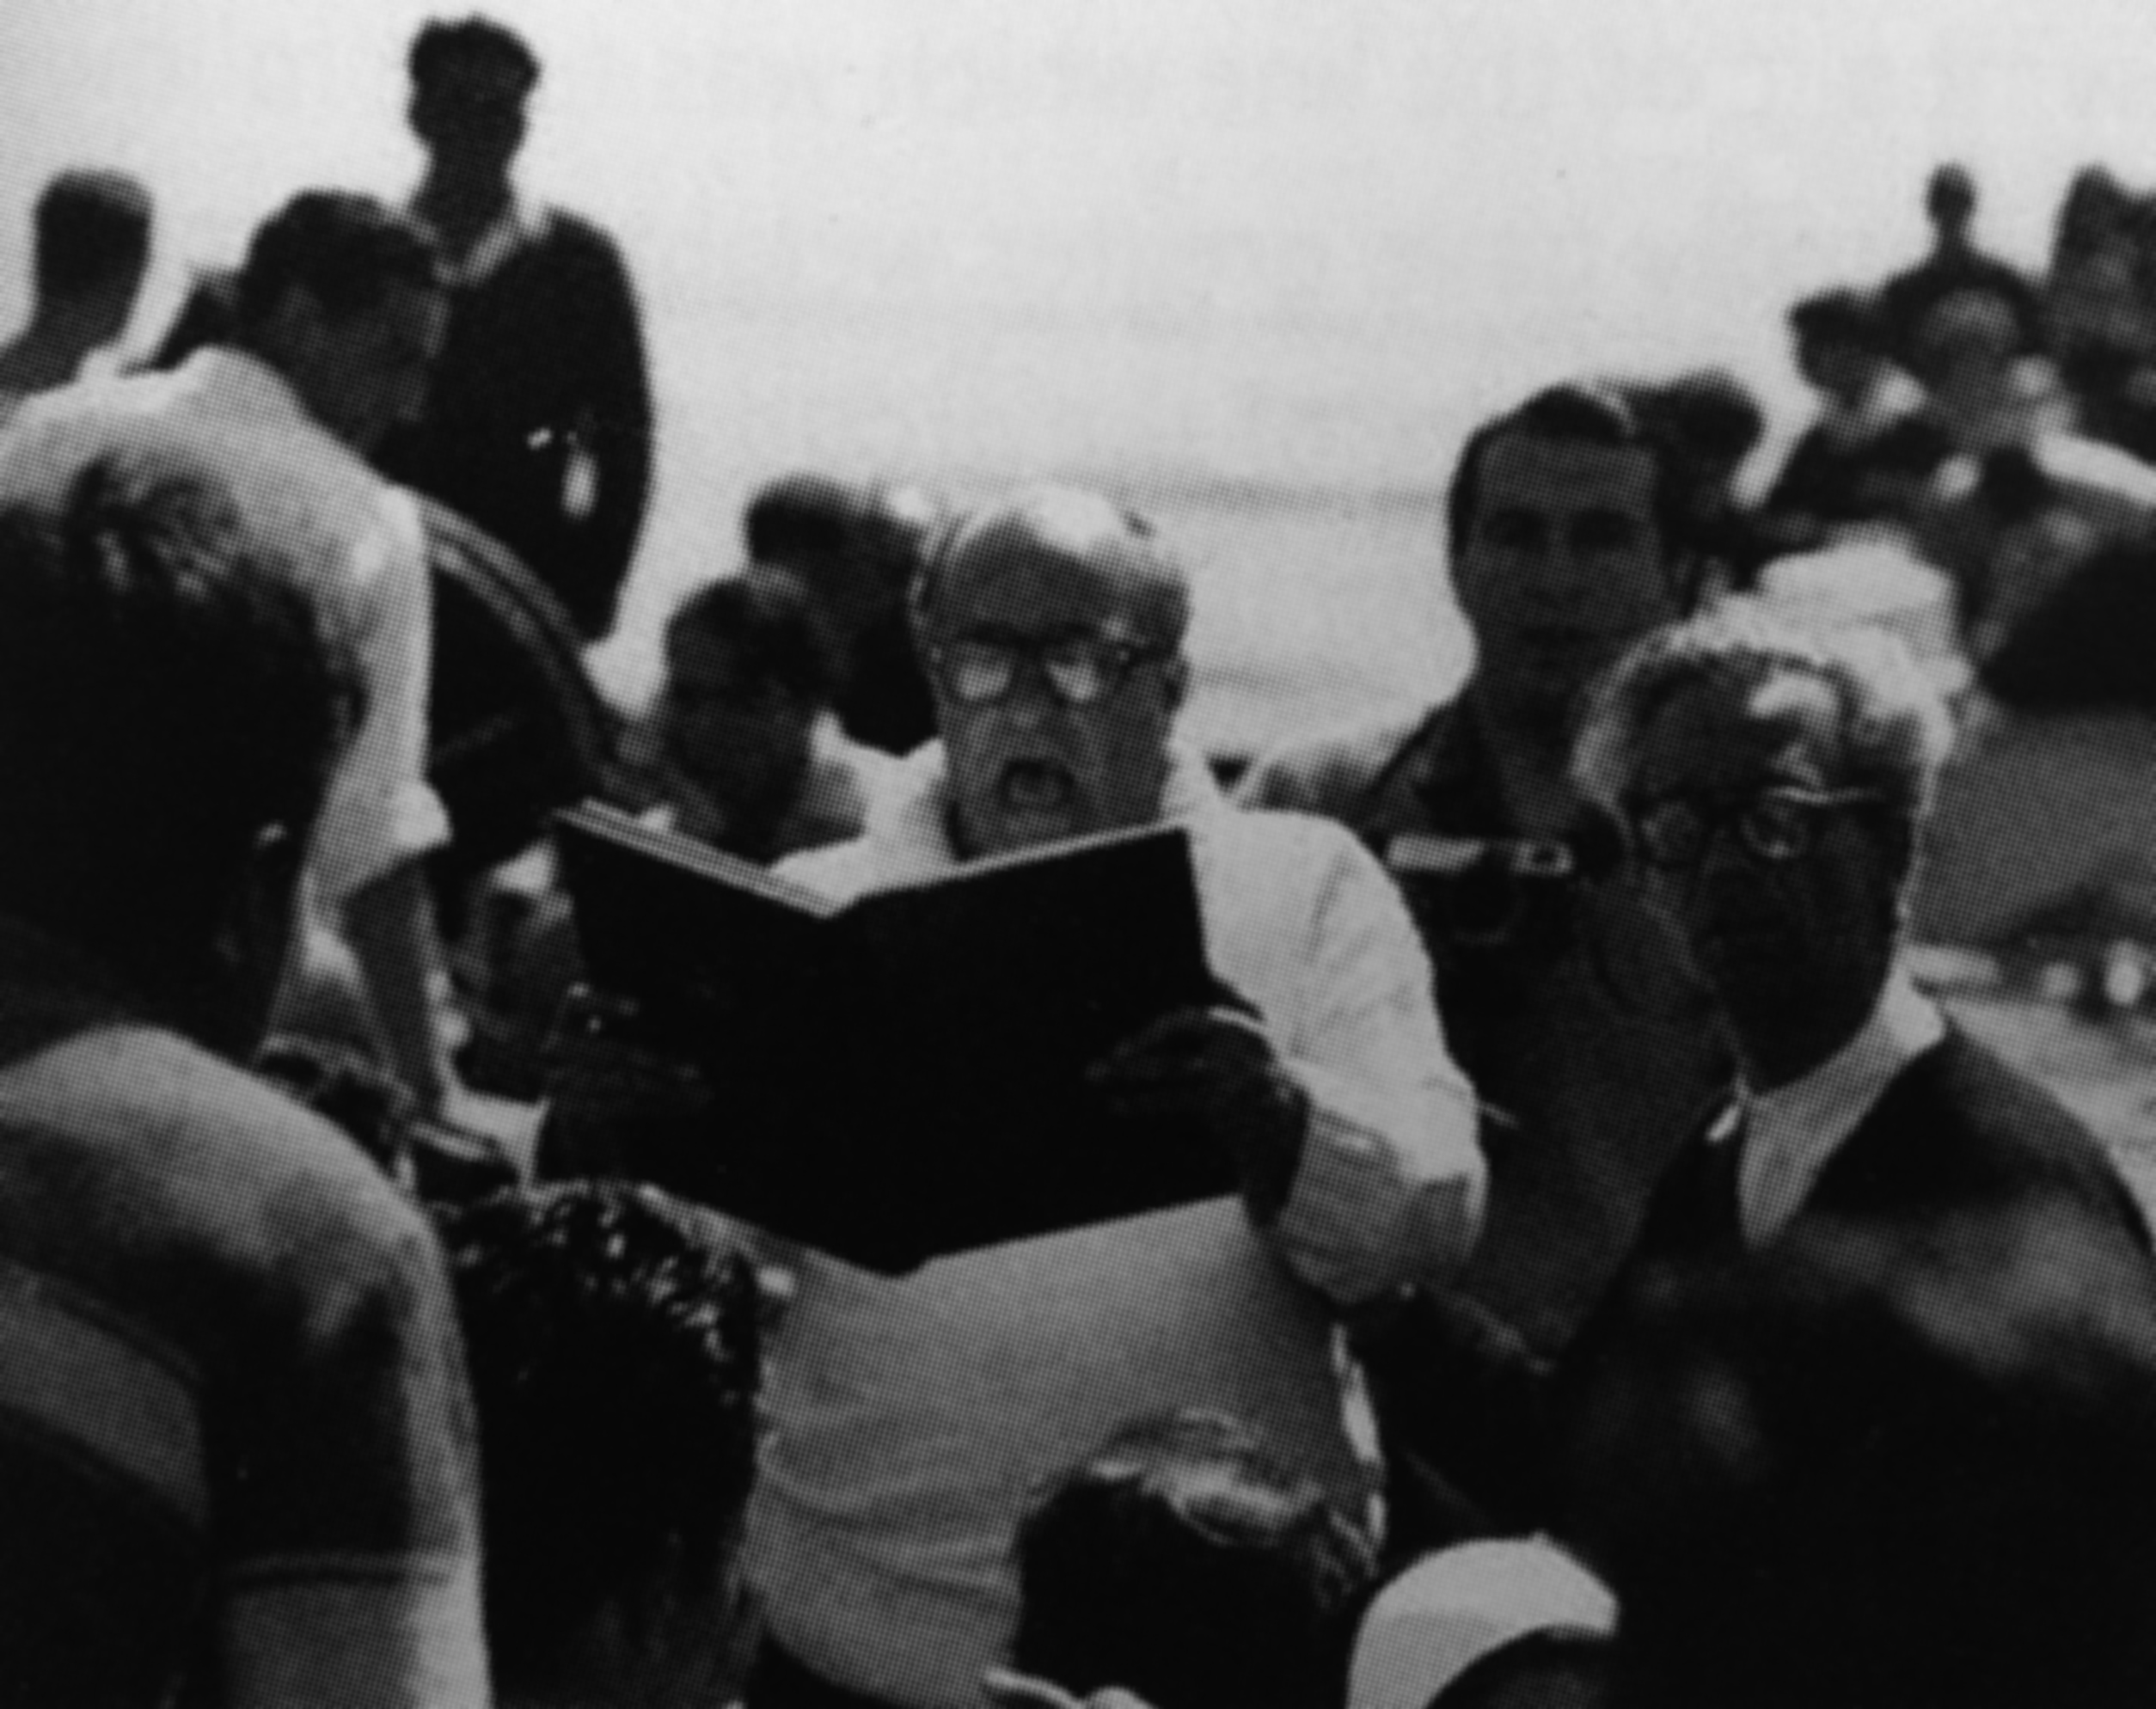

Figure 1: Godofredo Iommi (reading) and Alberto Cruz (right),

from Perez de Arce, Rodrigo et al (2003) *Valparaiso School Open City Group*, Basel: Birkhauser

The term ‘Valparaiso School’ is often applied to the school of architecture, design and arts of the Catholic University of Valparaiso, in specific relation to a novel academic approach initiated in 1952 and established in 1967 through an academic reform. The shift in teaching strategies implied the rejection of a Beaux-Arts-inspired syllabus in favour of a particularly local approach that involved new interests, processes and products, in part inspired by some aspects of imported heroic modernism. The main promoters of this change were Alberto Cruz, architect, and Godofredo Iommi, poet.

Alberto Cruz was born in 1917, studied architecture at the Catholic University in Santiago from 1934 onwards. After graduating, he became a teacher there and participated in the movements to change the school’s syllabus in 1949. In 1975 he received the National Architecture Award, given by the Chilean Architects’ Association. Godofredo Iommi, Argentinian, was born in 1917 and studied two years of Economics in Buenos Aires, without finishing. Instead, he started a poetic practice, inspired by modern Chilean poet Vicente Huidobro. Iommi died in Viña del Mar in 2001.

Both Cruz and Iommi joined the Valparaiso School in 1952. Cruz was invited to the Valparaiso School by its rector, Jorge Gonzalez. Cruz accepted the nomination, with the condition that Iommi and six other teachers joined as well – these were Francisco Méndez, Miguel Eyquem, Jaime Bellalta, Fabio Cruz Prieto, José Vial Armstrong y Arturo Baeza. This first act of collectivism would permeate the entire ethos of the school under the influence of Cruz and Iommi.

Immediately after joining, they would create the Institute of Architecture, a figure that would allow for innovative forms of research and teaching within the School. Under the influence of Cruz and Iommi, they started to explore interests that were foreign to the traditional academic teaching of the other schools of architecture in the country. Central among them was the relation between poetry and architecture: the spoken word was considered central to any founding act to be sustained by architecture. Another key interest was the territory, and more specifically, the spatiality of South America. The School had continental ambitions, drawing its inspirations from Mexican historian Edmundo O’Gorman (brother of Juan O’Gorman, notable Mexican modern architect). Both the relation between poetry and architecture and the interest in the territory would inform a series of creative processes and distinctive products that set the work of this school apart from its context.

Among the new methods put forward by Cruz and Iommi were the centrality of direct observation, the importance of sketches and notes produced in situ, *en ronda* creation (creation in a circle), and the *phalène*. The latter was invented by Iommi while living in Paris in 1955, and was defined as a poetic improvisation performed in public, with the participation of other artists and passers-by. All these methodological aspects, together with the importance of the collective and the territory, were put in practice through two very distinctive products/processes, perhaps the better-known outcomes of the Valparaiso School: the *travesias* and the Open City.

The *travesias*, voyages or journeys into the South American territory, were preceded by the poem *Amereida* (1967)*,* which reflects upon a trip taken by some teachers and alumni between Patagonia and Bolivia, and *Amereida II* (1982). The first *travesia* as part of the academic syllabus was executed in 1984, and from then on followed one per year. *Amereida III* (1991) publishes the *travesias* made between 1984 and 1988, and a record of the subsequent journeys up to today can be found in the school’s website. These circular trips involve descriptive and creative activities, such as poem reading and the erection of light structures. The principles behind the *travesias* are the ‘thesis of our own north’ and South America as an ‘inland sea’; the interests are said to be political, with a focus on boundaries and frontiers.

The Open City was founded in 1970, after the creation of the Amereida Cultural Corporation, academically associated with the school but legally independent from it. The corporation acquired some land in the coastal area of Ritoque and, from then on, the Valparaiso School teachers and students have subsequently engaged in the construction of particular structures and buildings. Notable amid the structures are the *hospederias,* or lodges, designed to host students and teachers, that provide the space for the kind of collective learning promoted by the school (Double lodge, 1974; Pie de Cruz, 1977; Design, 1977; Dormitory, 1978; Nail, 1980; Wanderer’s, 1981; Entrance, 1982; Study, 1987; Rosa de los Vientos, 1998; Garden, 1998; Signs, 2002). Together with these buildings, within the territory of the Open City, there also are a series of loose buildings (Igloo, 1971; Bathrooms, 1971; Music Room, 1972; Palace of Dawn and Dusk, 1983; House of Names, 1992; Beam Hall, 1992), *agoras* (Tronquoy, 1972; Guests, 1978), gardens (Bo Cenotaph, 1982), a cemetery (1976), a chapel (1999) and an amphitheatre (2001), plus a collection of sculptural structures (Water Tower, 1974; the Well, 1976).

All these elements (collectivism, poetry and architecture, territory, *phalènes*, *Amereida*, *travesias*, Open City) could be understood as an original interpretation of modernism as developed in Europe. Both Le Corbusier (an acknowledged referent), the Bauhaus and the Ulm School had a great influence over the Valparaiso School. ‘Life as art’, the dissolution of authorship, a collective way of life and a common initial syllabus for art, design and architecture were traits that the Valparaiso School adopted from modernist initiatives stemming from Europe.

The Valparaiso School remains to these days attached to the programme devised by Cruz and Iommi, although some discussions have been undertaken to update the school’s identity since 2007. The school’s impact over the profession and discipline in Chile is usually understood as anecdotal, mainly due to the very disengagement from urban, social and technical issues that the school promoted. This disengagement, however, could be seen as a symptom of the general practice of architecture in the last third of the 20th century. The flight from the urban into landscape mirrors the withdrawal from the public into the private – the most representative figure of Chilean architecture being the house in the white mountain. The Valparaiso School, by retreating to the dunes and choosing the language of poetry, severed its links with the social: a focus on words does not secure the presence of a dialogue.

**List of works**

1971 Igloo (Boris Ivelic)

1971 Bathrooms (Boris Ivelic)

1972 Tronquoy Agora (Open City Group – OCG)

1972 Music room (Alberto Cruz, Juan Purcell, OCG)

1974 Double lodge: Machine lodge and Banquet lodge (Alberto Cruz, OCG)

1974 Water Towers (Isabel Reyes, OCG)

1976 Cemetery (OCG)

1976 The Well sculpture (Claudio Girola)

1977 Pie de Cruz lodge (Fabio Cruz, OCG)

1977 Design lodge (OCG)

1978 Dormitory lodge (David Jolly, OCG)

1978 Guests agora (Juan Purcell, OCG)

1980 Nail lodge (OCG)

1981 Wanderer’s lodge (Miguel Eyquem, OCG)

1982 Entrance lodge (Boris Ivelic)

1982 Bo Cenotaph garden (Alberto Cruz, Tomás Browne)

1982 Palace of Dawn and Dusk (Alberto Cruz, Jorge Sanchez, OCG)

1987 Study Lodge (Fabio Cruz, David Jolly, Juan Purcell)

1990 Design Workshop (Fabio Cruz, Juan Ignacio Baixas)

1991 Workshop (Patricio Caraves, David Jolly)

1993 Bean hall (Juan Ignacio Baixas, Fabio Cruz)

1995 New Wanderer’s lodge (Manuel Casanova)

1996 Nail gallery (OCG)

1998 Rosa de los Vientos lodge (David Luza)

1998 Garden lodge (Iván Ivelic)

1999 Chapel (Patricio Caraves, Jorge Sanchez, Juan Purcell, OCG)

2001 Cemetery Amphitheatre (Jorge Sanchez, Juan Purcell, OCG)

2002 Lodge of the signs (Rodrigo Lorca, OCG)

**References and further readings**

Mihalache, Andreea (2006) “Huellas de ciudad abierta” en ARQ n° 64, pp. 24-27

Perez Oyarzún, Fernando and Rodrigo Perez de Arce (2003) *Valparaiso school / Open City group,* Basel: Birkhauser.

Perez Oyarzún, Fernando, Rodrigo Perez de Arce, Horacio Torrent and Malcom Quantrill (2010). *Chilean modern architecture since 1950,* College Station: Texas A & M University Press.

Pendleton-Jullian, Ann M. (1996) *The road that is not a road and the open city, Ritoque, Chile*, Cambridge (Mass.): MIT Press

Amadei, Gian Luca (2008) “Valparaiso School Chile” in Blueprint 270, pp 34-39.

[www.amereida.cl](http://www.amereida.cl)

<http://travesias.ead.pucv.cl>

**Visual material**

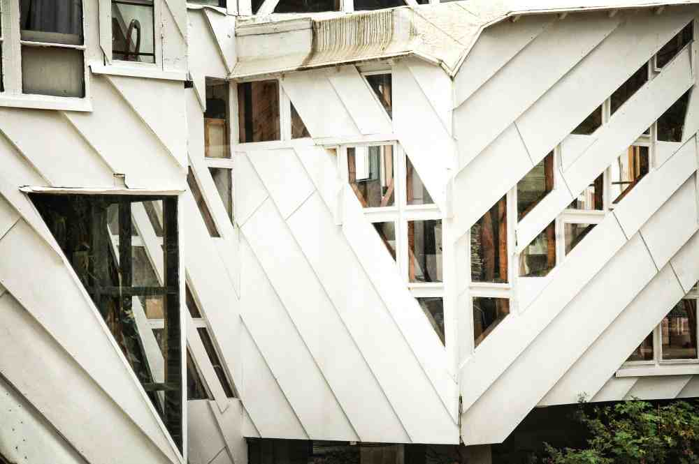

Figure 2: Gallery lodge (http://static.plataformaarquitectura.cl/2013/05/12/ciudad-abierta-de-ritoque-paisaje-habitado-44-anos-despues/51842ff4b3fc4b4d52000055_ciudad-abierta-de-ritoque-paisaje-habitado-44-a-os-despu-s_adsc_0113-jpg/)

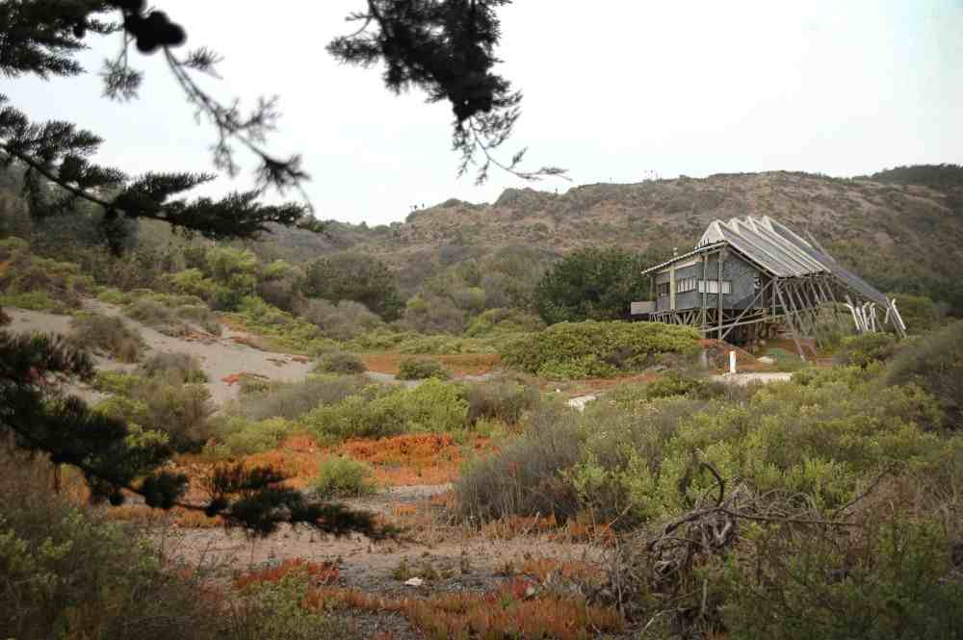

Figure 3: Entrance lodge (http://www.plataformaarquitectura.cl/2013/05/12/ciudad-abierta-de-ritoque-paisaje-habitado-44-anos-despues/518430e1b3fc4be35b00004a_ciudad-abierta-de-ritoque-paisaje-habitado-44-a-os-despu-s_adsc_0183-jpg/)

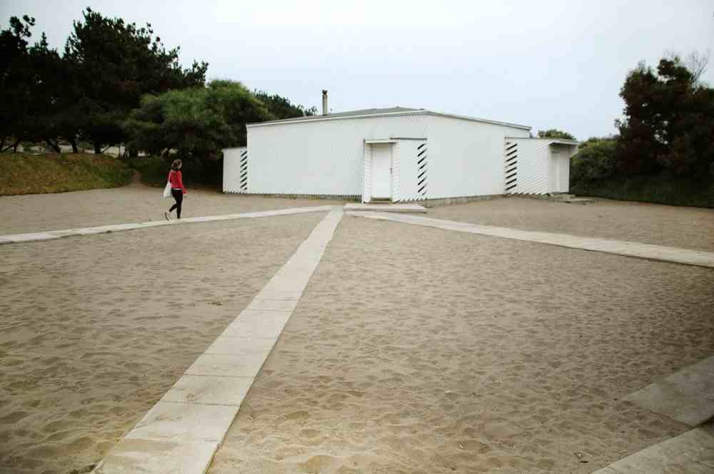

Figure 4: Music room (http://www.plataformaarquitectura.cl/2013/05/12/ciudad-abierta-de-ritoque-paisaje-habitado-44-anos-despues/51843142b3fc4b3b17000058_ciudad-abierta-de-ritoque-paisaje-habitado-44-a-os-despu-s_adsc_0225-jpg/)

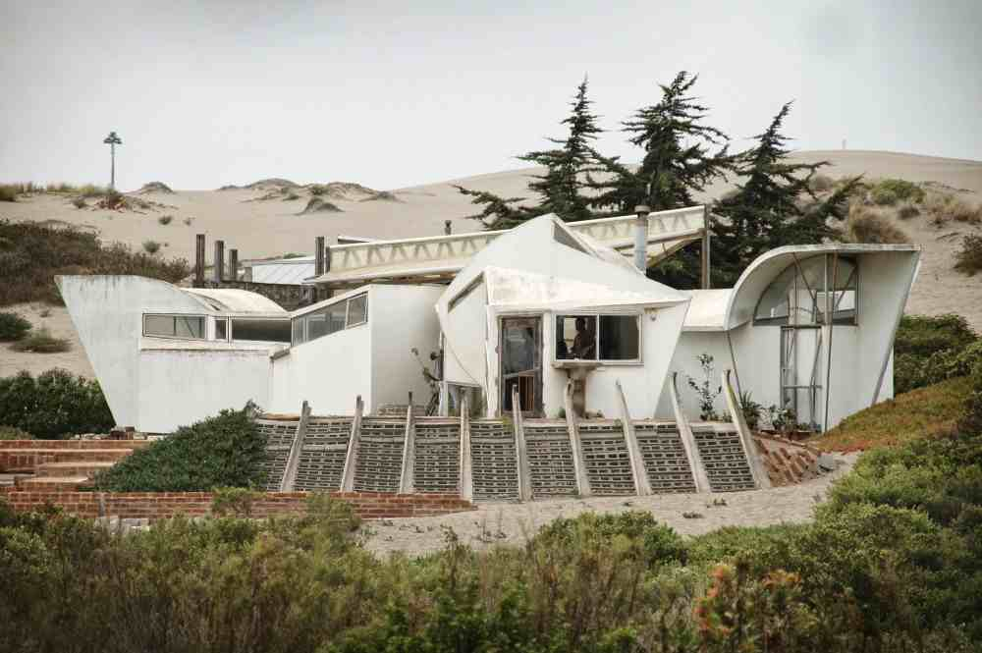

Figure 5: Rosa de los Vientos lodge (http://www.plataformaarquitectura.cl/2013/05/12/ciudad-abierta-de-ritoque-paisaje-habitado-44-anos-despues/5184312eb3fc4b4d5200005a_ciudad-abierta-de-ritoque-paisaje-habitado-44-a-os-despu-s_adsc_0221-jpg/)

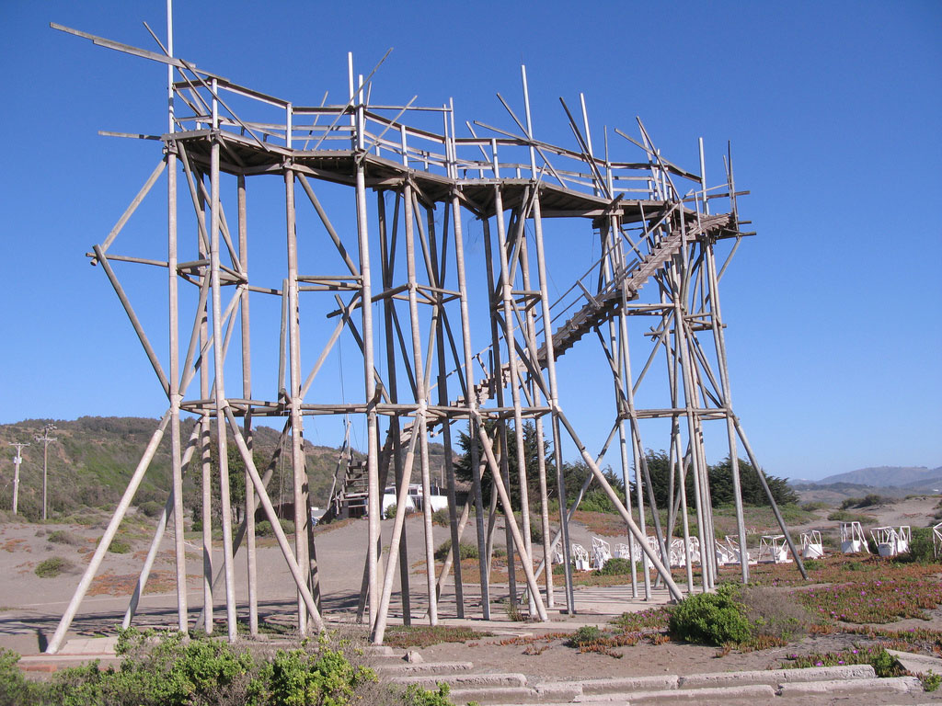

Figure 6: Water Towers (http://arquitecturamashistoria.blogspot.co.uk/2009/11/ciudad-abierta-de-ritoque-un.html)

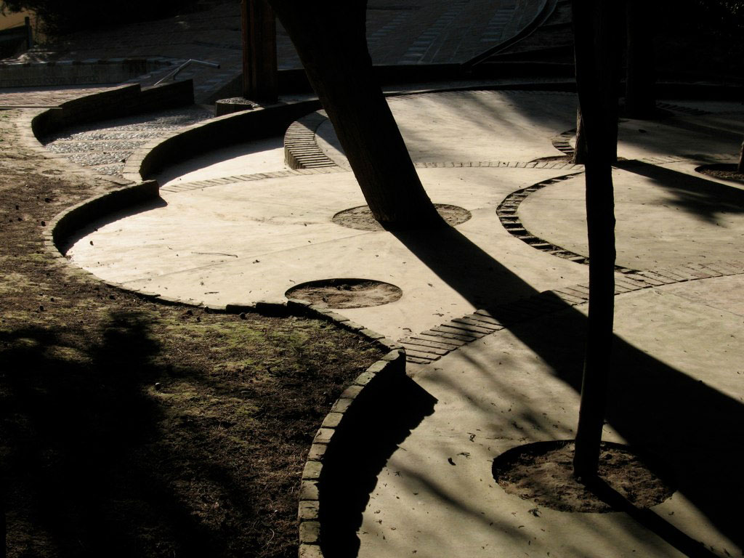

Figure 7: Cemetery (http://arquitecturamashistoria.blogspot.co.uk/2009/11/ciudad-abierta-de-ritoque-un.html)

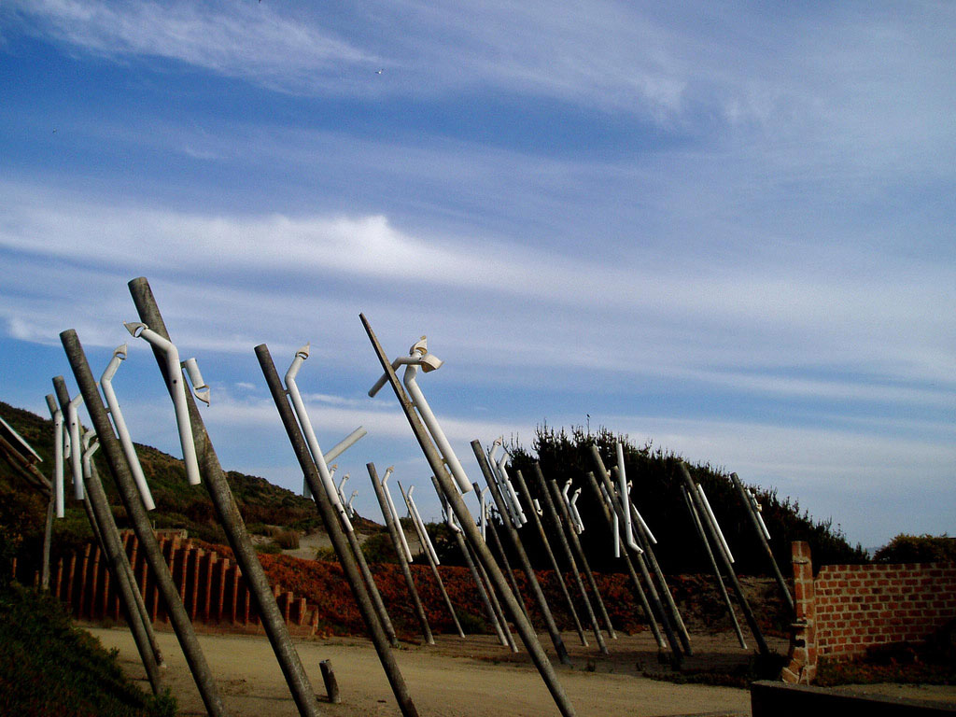

Figure 8: Eolic Sculpture (http://arquitecturamashistoria.blogspot.co.uk/2009/11/ciudad-abierta-de-ritoque-un.html)